Pink Ribbon Riders - Mail In Form – Cash OR Polaris Snowmobile Raffle
$5000.00 OR Patriot 9R Indy VR1 137 Dynamix
Drawing Date 2/17/2027 – License # R87356
TICKET AND PAYMENT INFORMATION ~ 1 ticket for $30.00 or 2 tickets for $50.00 / 3 =$80.00 / 4 = $100.00

Number of tickets you would like _________ Check Amount $ ______________ Check #__________________

Is your check in a different name than what you want the tickets above? Yes / No

Notes to Pink Ribbon Riders ______________________________________________________________________

- CREDIT CARD – Scan this QR code and you can pay with credit card
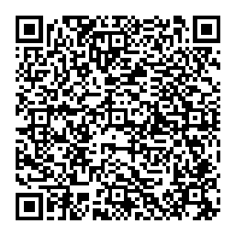

TICKET INFORMATION ~ PLEASE PRINT

NAME ON TICKET: FIRST __________________________________ LAST__________________________________

Mailing Address___________________________________________ City_________________________________

State________________________________________Zip____________________________________

Phone: ( ) ___________________________Email_________________________________________________

- Your ticket is not valid if the above is not filled out completely.
RULES and INFORMATION OF RAFFLE

Mail this form to: Pink Ribbon Riders, 5420A Beckley Road Suite 334, Battle Creek, MI 49015

All rules of raffle are posted on www.pinkribbonriders.com website.

Your ticket number/s will be emailed to you – Please provide a current email address.

